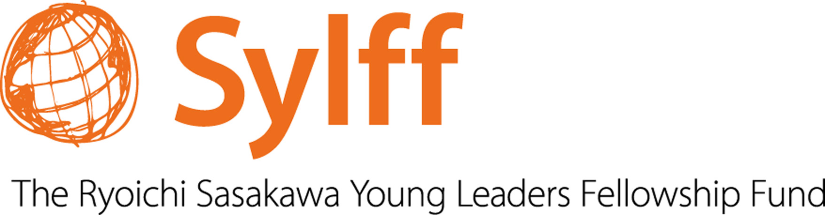
THE JU-SYLFF ASSOCIATION
Cordially Invites You
To

JU-SYLFF: A Celebration of 10 Glorious Years

Leadership and Governance

What Matters More?

Celebratory Speech
by
Yohei Sasakawa

(Chairman of Nippon Foundation, WHO Goodwill Ambassador for Leprosy Elimination)

Venue: Gandhi Bhavan, Jadavpur University
Date: September 24, 2013
Inauguration: 11 a.m.

